

Stonefield Homes, LLC

Commercial insurance proposal

Presented by: Kyle L Cardwell  
kcardwell@swinglecollins.com

(972) 387-6739

13760 Noel Road, Suite 600

Dallas, TX 75240

Table of Contents

Why Choose Swingle Collins? 3

Your Trusted & Knowledgeable Advisors 4

Thorough & Accurate Coverage 5

General Liability 6

Umbrella / Excess Liability 9

Builder’s Risk 11

Additional Coverage to Consider 13

Premium Summary 14

We’re Here for You 24/7 15

Why Choose Swingle Collins?

As one of the largest privately-owned insurance agencies in Texas, Swingle Collins & Associates is able to provide solutions for even the most unique and complex risks. Our status as an independent firm allows us to offer the type of tailored service and coverage options that our clients both expect and deserve.

Because of our growth, success and level of service, leading carriers have awarded us top-tier access, which directly benefits our clientele with a broader range of choices and services. By adopting a consultative approach and staying at the forefront of emerging trends, we’re able to deliver options that are selected specifically to ensure that your business, assets, family, and employees have the level of coverage they need.

Our elite team of risk advisors is considered best-in-class by industry peers and clients alike. We’ve been named a Top 100 Independent Property/Casualty Agency by *Insurance Journal* and rated among the “Best Places to Work” by *Insurance Journal* and the *Dallas Business Journal*.

In everything we do, we strive to be an extension of your company and family wealth management team, providing you with the peace of mind that your assets are properly protected — and that your needs will always come first.

Your Trusted & Knowledgeable Advisors

|  |  |  |
| --- | --- | --- |
|  |  | Personal Risk Advisor |
|  |  | *Your coverage expert and partner.* |
|  |  | **Kyle L Cardwell CLCS, MSM** |
|  |  | (972) 387-6739 |
|  |  | kcardwell@swinglecollins.com |
|  |  |  |

|  |  |  |
| --- | --- | --- |
|  |  | Account Manager |
|  |  | *Provides support for claims, billing, and coverage questions.* |
|  |  | **Erin Grady MBA, CISR** |
|  |  | (972) 715-8775 |
|  |  | egrady@swinglecollins.com |
|  |  |  |

|  |  |  |
| --- | --- | --- |
|  |  | Assistant Account Manager |
|  |  | *Supports the team and will often contact you to follow up on  outstanding items, billing, and renewals.* |
|  |  | **Jessica Staggs** |
|  |  | (972) 715-8779 |
|  |  | jstaggs@swinglecollins.com |
|  |  |  |

|  |  |  |
| --- | --- | --- |
|  |  | Certificate and Evidence of  Property REquests |
|  |  |  |
|  |  | **Services Department** |
|  |  | services@swinglecollins.com |
|  |  |  |

Thorough & Accurate Coverage

Our goal is to make sure that you always have adequate coverage in place for your family, your assets, and your business. That’s why it’s important to contact us when there are any changes that may have a bearing on your insurance program. Your insurers evaluate and accept risks on the basis of the information you’ve given; any outdated information could lead to complications in the event of a loss.

* **These changes may include, but are not limited to:**
* Change of mailing and/or billing address.
* Changes in your personnel who are responsible for insurance decisions.
* Personnel traveling overseas, on temporary assignment overseas, or working on military bases.
* Acquisitions, creation of new companies or subsidiaries, and/or mergers in which you are involved, or that change the legal corporate structure in any way.
* Purchase, construction, or occupancy of new premises, either foreign or domestic. This includes alteration, vacating the premises, temporary inoccupancy, or extension or demolition of existing premises.
* Increase in the value of a building or business personal property, for both scheduled and unnamed locations.
* Transfer of business personal property, inventory, or stock to a new or temporary location.
* Any addition of new locations, equipment, or vehicles, whether they are hired, leased, or borrowed.
* Changes in processes, occupancy, products, or business operations.
* Addition, alteration or temporary disconnection of fire or burglary protection systems.
* Use of aircraft or watercraft, whether or not you own them.
* Major changes in the value or nature of goods being shipped.
* Employment of personnel in states in which you were previously not doing business.
* Election or appointment of a new CEO or COO, or any change in control of either the company’s Board of Directors or stock ownership.
* Changes in ERISA Plan Assets.
* Addition of new drivers for the company.
* Insurance requirements for a lease or business contract that require additions or changes to your existing coverage.

General Liability

|  |  |
| --- | --- |
| **Issuing Company** | **United Specialty Insurance Company** |
| **Policy Number** | **AUN2215042** |
| **Policy Term** | **9/1/2023 to 9/1/2024** |

Named Insureds

| Insured | Interest |
| --- | --- |
| Stonefield Homes, LLC | First Named Insured |

Coverages

|  |  |
| --- | --- |
| Description | Limit |
| General Aggregate | $2,000,000 |
| Products / Completed Operations Aggregate | $2,000,000 |
| Each Occurrence | $1,000,000 |
| Personal and Advertising Injury | $1,000,000 |
| Fire Damage (Any One Fire) | $100,000 |
| Medical Expense (Any One Person) | $5,000 |
| Property Damage/Bodily Injury Deductible (including expenses) | $5,000 |
| Medical Payments Deductible – Per Claimant | $5,000 |

Locations and Exposures

| Loc | | Bldg | Description | Exposure | Premium Basis | |
| --- | --- | --- | --- | --- | --- | --- |
| **1** | **1** | | **5001 LBJ Freeway, Suite 850, Dallas, Texas 75244** | | | |
|  | | | Construction - Home Builder | $13,000,000 | | Receipts |

**Rate**

$4.46 per $1,000 Gross Receipts estimated at $13,000,000

$4.01 per $1,000 Gross Receipts in Excess of $13,000,000

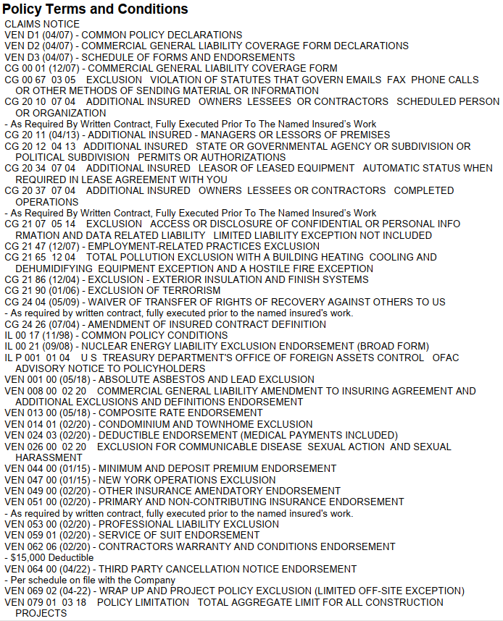Endorsements

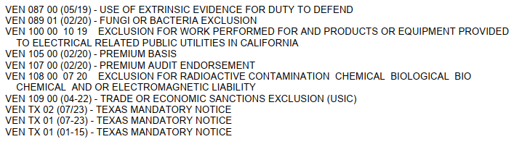Endorsements (cont.)

Subjectivities

Subject to 25% Minimum Earned Premium

Subject to 100% Minimum and Deposit

All Policy Fees are Fully Earned at Inception

Terrorism Coverage is available for purchase for an Additional Annual Premium of $1,740.00 + taxes

Required to Bind

Signed and Dated ACORD Applications

Completed, Signed and Dated TRIA (Terrorism Risk Insurance Act) Rejection Form

Favorable Subcontractor Agreement - It is Required to Contain Hold Harmless, Indemnification (IN BOLD) and AI in Favor of the Insured. Limit Requirement to be Stated in Agreement as Well of ($1M Per Occurrence/$2M Aggregate/$2M Products/Completed Operations)

Excess Liability

|  |  |
| --- | --- |
| **Issuing Company** | **United Specialty Insurance Company** |
| **Policy Number** | **BTN2219203** |
| **Policy Term** | **9/1/2023 to 9/1/2024** |

Named Insureds

| Insured | Interest |
| --- | --- |
| Stonefield Homes, LLC | First Named Insured |

Coverages

|  |  |
| --- | --- |
| Description | Limit |
| General Aggregate | $2,000,000 |
| Each Occurrence | $2,000,000 |

Underlying Coverages

|  |  |  |  |
| --- | --- | --- | --- |
| Description | Carrier / Policy # | Policy Period | Limit |
| General Liability Each Occurrence  General Aggregate Product & Completed Ops Agg Personal & Advertising Injury | United Specialty Insurance Co / AUN2215042 | 9/1/2023 to 9/1/2024 | $1,000,000 $2,000,000 $2,000,000 $1,000,000 |
| Employers Liability  Each Accident  Disease Each Employee  Disease Policy Limit | Texas Mutual Insurance Company /0001285647 | 4/7/2023 to 4/7/2024 | $1,000,000 $1,000,000 $1,000,000 |

**Endorsements**

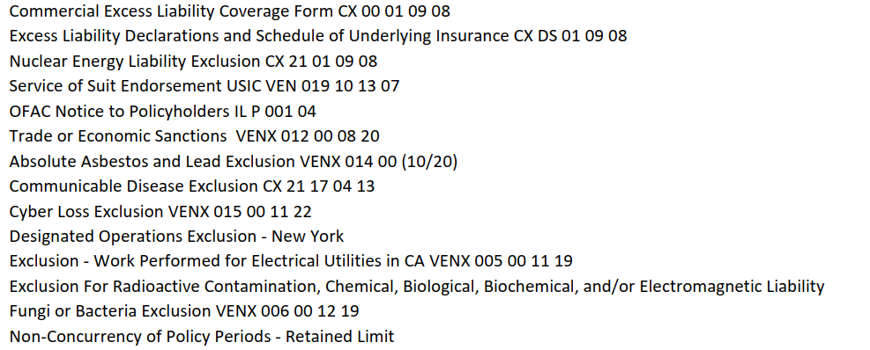

**Subjectivities**

Subject to 25% Minimum Earned Premium

Policy Fees are Fully Earned at Inception

**Required to Bind**

Completed, Signed and Dated ACORD Applications

Signed and Selected Terrorism Risk Insurance Act (TRIA)

Favorable Subcontractor Agreement - It is Required to Contain Hold Harmless, Indemnification (IN BOLD) and AI in Favor of the Insured. Limit Requirement to be Stated in Agreement as Well of ($1M Per Occurrence/$2M Aggregate/$2M Products/Completed Operations)

Builder’s Risk

|  |  |
| --- | --- |
| **Issuing Company** | **Federal Insurance Company** |
| **Policy Number** | **6722490** |
| **Policy Term** | **9/1/2023 to 9/1/2024** |

Named Insureds

| Insured | Interest |
| --- | --- |
| Stonefield Homes, LLC | First Named Insured |

Coverages

| Description | Limit |
| --- | --- |
| Residential Construction Works – Any One Project | $500,000 |
| Contract Works | $5,000,000 |
| At Temporary Location | $100,000 |
| Transit | $100,000 |
| Cause of Loss | Special |
| Earthquake Annual Aggregate  Deductible | $500,000 $50,000 |
| Flood Annual Aggregate  Deductible | $500,000 $100,000 |
| All Other Perils Deductible | $5,000 |
| Wind/Hail Deductible | $100,000 |

**Number of Starts**

20

**Subjectivities**

Subject to $10,000 Minimum Earned Premium

Terrorism Coverage may be Rejected for an Annual Premium Savings of $50.00 (signed rejection required at binding)

Endorsements

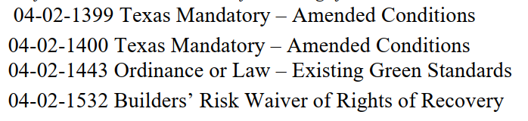

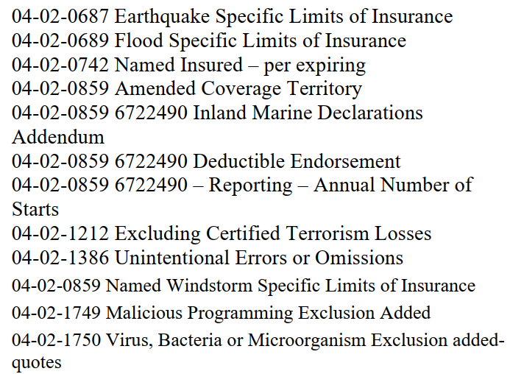

Form 04-02-0859 – Definition of Named Windstorm

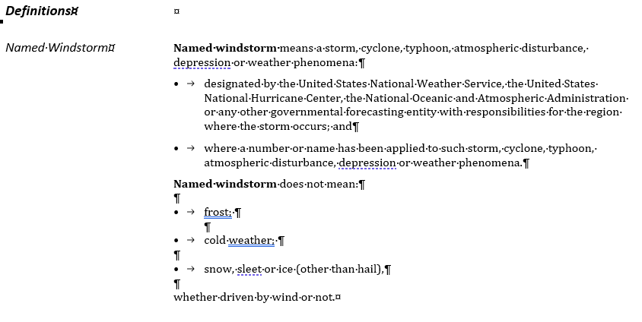

Additional Coverage to Consider

Below is a list of coverages for your consideration:

* Accident
* Bonds
* Builders Risk
* Business Income (Loss of Income and Extra Expense)
* Cargo
* Crime
* Cyber Liability
* Deductible Buy Back
* Dependent Property
* Directors & Officers Liability
* Earthquake
* Employed Lawyer
* Employee Benefits Liability
* Employment Practices Liability
* Fiduciary Liability
* Flood
* Foreign Liability or Travel Insurance
* Group Excess
* Higher Liability Limits
* Inland Marine
* Kidnap and Extortion
* Pollution Liability
* Professional Liability
* Trade Credit
* Transit
* Workplace Violence

Premium Summary

|  |  |  |
| --- | --- | --- |
| Coverage | Expiring Premium | Renewal Premium |
| **General Liability** | **$63,769** | **$62,718.92** |
| Gross Receipts | *$13,000,000* | *$13,000,000* |
| Rate per $1,000 Gross Receipts | *$4.46* | *$4.46* |
| **Excess Liability** | **$25,980** | **$26,887.03** |
| **Builders Risk** | **$31,013** | **$12,950.00** |
| Estimated Number of Starts | *50* | *20* |
| Cost per Start | *$615.00* | *$645.00* |
| **Grand Total** | **$120,762.00** | **$102,555.95** |

Payment Options

|  |  |  |  |
| --- | --- | --- | --- |
| Down Payment Amount | Check Payable to | # of Installments | Installment Amount |
| $37,655.95 | Swingle Collins & Associates | 11 | $2,949.27 |

*This proposal is provided as an overview of your policy. You must refer to the provisions found in your policy for the details of your coverage, terms, conditions, and exclusions that apply.*

We’re Here for You 24/7

We place a high priority on providing superior service, and on being there for you whenever you need us. We’re always happy to take your calls, answer emails and resolve any issues during standard business hours. Outside office hours, we make it easy to get the information you need with 24/7 account access through your computer or device.

Whether at your office, at home, or on the road you can log into your account anytime, anywhere to:

* Review your coverage and current policy information.
* Request changes to your policies or contact information.
* Create and send certificates of insurance and auto ID cards on demand.
* Report a claim or loss

Your time is valuable. Our goal is to help you quickly and easily get the information or resources you need, whether you’re dealing with us in person, on the phone or online

